Schéma de la base de données pour les Tps

|  |  |
| --- | --- |
| **Name of the table** | **Meaning** |
| ACCOUNT | The table records the bank accounts. Each of the customers can register multiple accounts each of which corresponds to a type of product provided by the bank.  (See more: PRODUCT) |
| ACC_TRANSACTION | The table records the transaction history between the bank and a certain account. |
| BRANCH | The branch, the branch of the bank |
| BUSSINESS |  |
| CUSTOMER | The customer table |
| DEPARTMENT | The department table of the bank |
| EMPLOYEE | The table of employees of the bank |
| OFFICER |  |
| PRODUCT | Products from the bank, for example:   * Savings account * Credit professions * Small business loans * ..... |
| PRODUCT_TYPE | Types of banking services:   * Customer's bank account * Loans to individuals and businesses * The insurance provider |

**5- The structure of the tables**

**5.1- ACCOUNT**

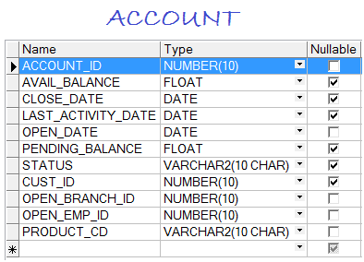

**5.2- ACC_TRANSACTION**

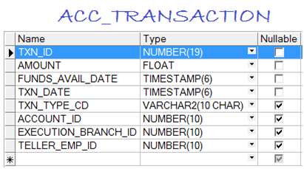

**5.3- BRANCH**

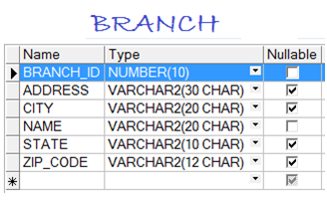

**5.4- BUSINESS**

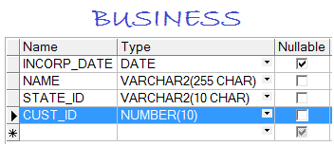

**5.5- CUSTOMER**

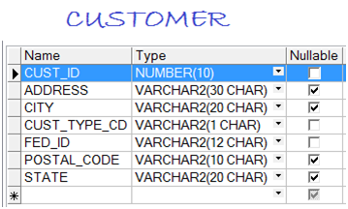

**5.6- DEPARTMENT**

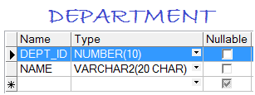

**5.7- EMPLOYEE**

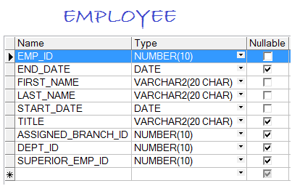

**5.8- INDIVIDUAL**

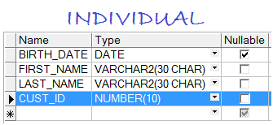

**5.9- OFFICER**

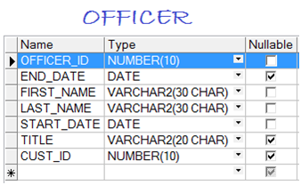

**5.10- PRODUCT**

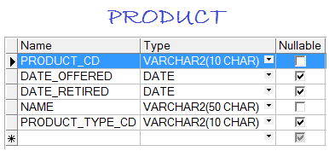

**5.11- PRODUCT_TYPE**

